INTERNSHIP REPORT

TITLE PAGE
TECHNOLOGY PROJECT: ONLINE SHOPPING
Submitted in partial fulfillment of the requirements for
the award of the degree of
FYUGP – B.Sc. Computer Science
Submitted by:
Name: TIYA THOMAS
Course: FYUGP B.Sc. Computer Science
Register no :PNAYSCS031
College: PRAJYOTI NIKETAN COLLEGE PUTHUKAD
University: CALICUT UNIVERSITY
Internship Organization:
ZIUKE INFOTECH THRISSUR
Internship Duration:
60 Hours (Company Training)
Project Title:
Online Shopping
Technologies Used:
Python, Django, HTML, CSS
Academic Year: [2024-2027]

ACKNOWLEDGEMENT

I express my sincere gratitude to the Ziuke infotech Thrissur for providing me with the opportunity to complete a 60-hour internship training as part of the FYUGP B.Sc. Computer Science curriculum. This internship served as a valuable platform to gain practical exposure to modern software development techniques and tools.
I would like to thank my training supervisor and mentors for their continuous guidance, technical support, and encouragement throughout the internship. Their clear explanations and patient mentoring helped me understand concepts related to Python programming, Django framework, and web development technologies effectively.
I am also thankful to Simi Varghese, Rincy T.A and all faculty members of the Computer Science Department, Prajyoti Niketan college puthukad , for incorporating this internship into the academic syllabus and for their constant motivation.
Finally, I extend my heartfelt thanks to my parents and friends for their moral support and encouragement, which played a significant role in the successful completion of this internship.

EXECUTIVE SUMMARY

This report presents a detailed description of the 60-hour company training internship undertaken at a ZIUKE INFOTECH THRISSUR as a part of the FYUGP B.Sc. Computer Science program. The internship focused on a practical technology project titled “Online Shopping.”
The main objective of the internship was to gain hands-on experience in software and web application development and to understand how theoretical computer science concepts are implemented in real-world systems. The project was developed using Python as the core programming language, Django as the backend web framework, and HTML and CSS for designing and styling the user interface.
During the internship, I learned about the structure of web applications, frontend–backend interaction, basic e-commerce workflows, and professional development practices. This internship enhanced my technical abilities, analytical thinking, and professional skills such as communication, teamwork, and time management. Overall, the training proved to be a meaningful and enriching learning experience.

CERTIFICATE

TABLE OF CONTENTS

- organization profile………………………………………………6
- internship overview………………………………………………7
- internship experience…………………… ………………………8
- learning reflection…………………………………….................10
- appendix…………………………………………………………10

CHAPTER 1: ORGANIZATION PROFILE

1.1 Introduction
The internship was carried out at ZUIKE INFOTECH THRISSUR that specializes in providing industry-oriented technical training to students. The organization focuses on enhancing practical knowledge and preparing students for real-world challenges in the field of information technology and software development.

1.2 Nature of the Organization
The organization is primarily engaged in:
- Technology-based training programs
- Web and software development training
- Programming language education
- Project-oriented learning
It aims to bridge the gap between academic education and industry expectations.

1.3 Vision
The vision of the organization is to create skilled and competent technology professionals who can contribute effectively to the IT industry.

1.4 Mission
The mission of the organization includes:
- Providing hands-on technical training
- Encouraging learning through real-world projects
- Developing problem-solving and analytical skills
- Promoting professional discipline and ethics

1.5 Organizational Environment
The organization maintains a professional, supportive, and learner-friendly environment. Trainers emphasize interactive learning, practical exercises, and continuous evaluation, which helps students gain confidence in technical skills.

CHAPTER 2: INTERNSHIP OVERVIEW

2.1 Duration of Internship
The internship was conducted for a total duration of 60 hours under company training guidelines. The training sessions included theoretical explanations, practical exercises, and project development.
2.2 Objectives of the Internship
The objectives of the internship were:
- To gain practical experience in web development
- To learn backend development using Python and Django
- To understand frontend design using HTML and CSS
- To apply theoretical concepts to practical projects
- To develop professional work ethics

2.3 Structure of the Internship
The internship was structured into the following phases:
- Introduction to web development concepts
- Python programming fundamentals
- Django framework basics
- Frontend development using HTML and CSS
- Project implementation and review

2.4 Tools and Technologies Used
- Python: Used for writing backend logic
- Django: Used to create and manage web applications
- HTML: Used for structuring web pages
- CSS: Used for styling and layout design

CHAPTER 3: INTERNSHIP EXPERIENCE
Project: Online Shopping

3.1 Introduction to Online Shopping
Online shopping refers to the process of purchasing goods and services over the internet using websites or applications. It is an important part of modern digital commerce.

3.2 Objectives of the Project
- To understand e-commerce system architecture
- To design user-friendly web pages
- To integrate frontend and backend components
- To gain experience in web application development

3.3 Description of the Project
The Online Shopping project is a basic web application that demonstrates the working of an e-commerce platform. It includes product display, navigation, and backend data handling.

3.4 System Development Process
The project was developed using the following steps:
- Requirement analysis
- Frontend design using HTML and CSS
- Backend implementation using Python and Django
- Testing and debugging

3.5 Features of the Online Shopping System
- Product listing and display
- Simple navigation
- Organized data management
- User-friendly interface

3.6 Advantages of Online Shopping
- Convenience and accessibility
- Time-saving
- Wide product availability

3.7 Challenges Faced
- Understanding Django framework concepts
- Integrating frontend with backend
- Debugging application errors

3.8 Skills Gained During the Project
- Web application development
- Logical and analytical thinking
- Problem-solving skills
- Team collaboration

CHAPTER 4: LEARNING REFLECTION

This internship was an enriching learning experience that significantly enhanced my technical knowledge and professional skills. It helped me understand how real-world web applications are developed using modern technologies.
The internship improved my confidence in programming, strengthened my problem-solving abilities, and taught me the importance of discipline, teamwork, and time management. The project on online shopping motivated me to further explore advanced technologies and build a strong career in computer science.

CHAPTER 5: APPENDIX

A. Internship Details
- Course: FYUGP B.Sc. Computer Science
- Internship Duration: 60 Hours
- Organization: ZIUKE INFOTECH THRISSUR
- Project Title: Online Shopping

B. Technologies Used
- Python
- Django
- HTML
- CSS

C. Learning Outcomes
- Practical exposure to web development
- Understanding of software project workflow
- Improvement in technical and professional skills

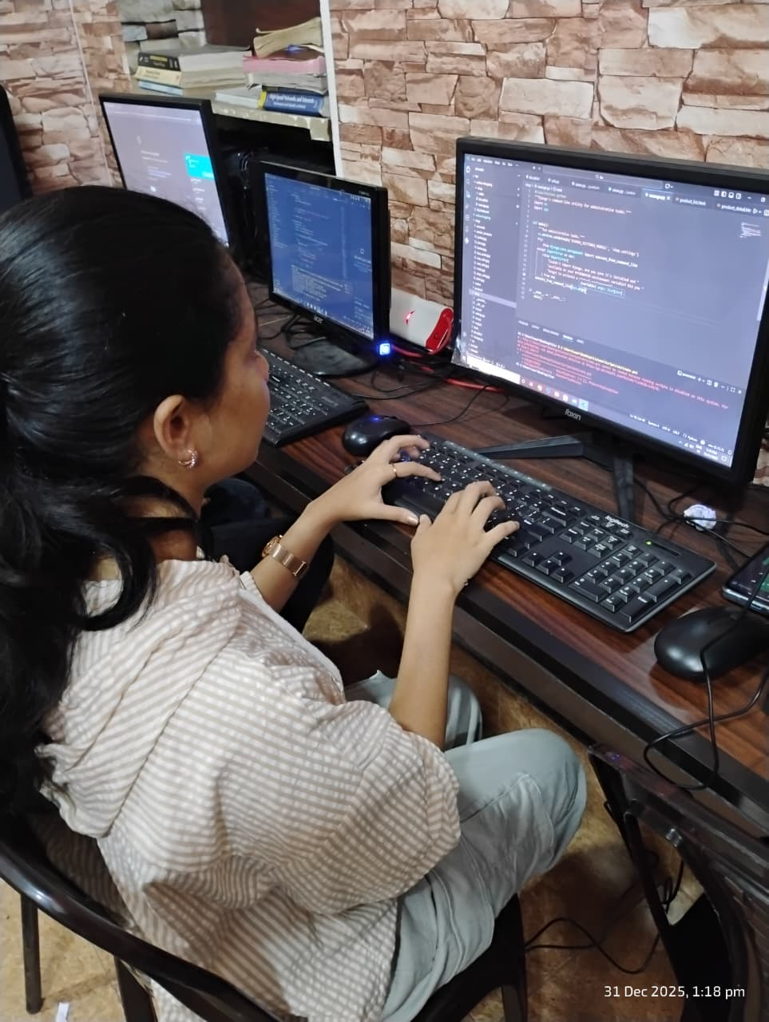

- Worksheet/activity book
- click here

